**Abdelrhman Yasser 221004349**

**Hazem El-Kanawati 221006745**

**Youssef Hani 221005893**

**Clinic Reservation System Report**

**Overview**

**The Clinic Reservation System is a database-driven application designed to manage various clinic operations, including patient records, doctor schedules, appointments, services, and invoices. The system uses SQL to store and manage data efficiently, ensuring data integrity and ease of access for users.**

**ER Diagram**

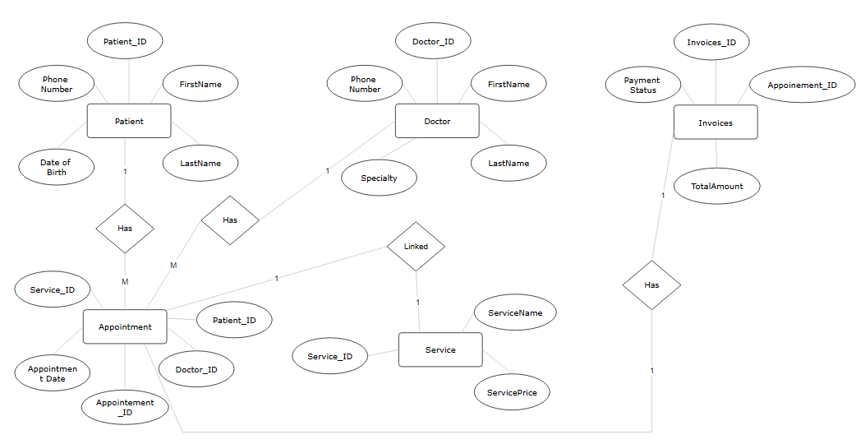

**Table Implementation**

**1. Patients Table**

**Schema:**

**CREATE TABLE Patients (**

**PatientID INT PRIMARY KEY,**

**FirstName VARCHAR(50),**

**LastName VARCHAR(50),**

**PhoneNumber VARCHAR(15),**

**DateOfBirth DATE**

**);**

**Sample Data:**

**INSERT INTO Patients VALUES**

**(1001, 'Ali', 'Mahmoud', '1234567890', '1990-01-15'),**

**(1002, 'Laila', 'Ahmed', '2345678901', '1985-06-25');**

**2. Doctors Table**

**Schema:**

**CREATE TABLE Doctors (**

**DoctorID INT PRIMARY KEY,**

**FirstName VARCHAR(50),**

**LastName VARCHAR(50),**

**Specialty VARCHAR(50),**

**PhoneNumber VARCHAR(15)**

**);**

**Sample Data:**

**INSERT INTO Doctors VALUES**

**(101, 'Ahmed', 'Ali', 'Cardiology', '1111111111'),**

**(202, 'Mahmoud', 'Hassan', 'Orthopedics', '2222222222');**

**3. Appointments Table**

**Schema:**

**CREATE TABLE Appointments (**

**AppointmentID INT PRIMARY KEY,**

**PatientID INT,**

**DoctorID INT,**

**AppointmentDate DATETIME,**

**ServiceID INT,**

**FOREIGN KEY (PatientID) REFERENCES Patients(PatientID),**

**FOREIGN KEY (DoctorID) REFERENCES Doctors(DoctorID),**

**FOREIGN KEY (ServiceID) REFERENCES Services(ServiceID)**

**);**

**Sample Data:**

**INSERT INTO Appointments VALUES**

**(54, 1001, 101, '2024-12-22 10:00:00', 101);**

**SQL Queries**

**Insert Query:**

**INSERT INTO Patients VALUES (1003, 'Omar', 'Hassan', '3456789012', '1978-03-10');**

**Delete Query:**

**DELETE FROM Appointments WHERE AppointmentID = 54;**

**Update Query:**

**UPDATE Patients SET PhoneNumber = '9999999999' WHERE PatientID = 1001;**

**Select Query:**

**SELECT * FROM Doctors WHERE Specialty = 'Cardiology';**

**Aggregate Query 1:**

**SELECT COUNT(*) AS TotalAppointments FROM Appointments;**

**Aggregate Query 2:**

**SELECT AVG(TotalAmount) AS AverageRevenue FROM Invoices;**

**Join Query 1:**

**SELECT Patients.FirstName, Doctors.FirstName AS DoctorName, Appointments.AppointmentDate**

**FROM Appointments**

**JOIN Patients ON Appointments.PatientID = Patients.PatientID**

**JOIN Doctors ON Appointments.DoctorID = Doctors.DoctorID;**

**Join Query 2:**

**SELECT Services.ServiceName, SUM(Invoices.TotalAmount) AS Revenue**

**FROM Appointments**

**JOIN Services ON Appointments.ServiceID = Services.ServiceID**

**JOIN Invoices ON Appointments.AppointmentID = Invoices.AppointmentID**

**GROUP BY Services.ServiceName;**

**Webpage Implementation**

**A simple PHP-based webpage interacts with the database:**

**Features:**

1. **Add Patients: Form to add new patient details.**
2. **View Appointments: Table listing all scheduled appointments.**
3. **Update Invoice Status: Interface to mark invoices as paid.**

**Code Example:**

**Add Patients:**

**<form method="POST" action="add_patient.php">**

**<input type="text" name="firstName" placeholder="First Name" required>**

**<input type="text" name="lastName" placeholder="Last Name" required>**

**<input type="text" name="phone" placeholder="Phone Number" required>**

**<input type="date" name="dob" required>**

**<button type="submit">Add Patient</button>**

**</form>**

**Backend Logic:**

**include 'db_connection.php';**

**$firstName = $_POST['firstName'];**

**$lastName = $_POST['lastName'];**

**$phone = $_POST['phone'];**

**$dob = $_POST['dob'];**

**$sql = "INSERT INTO Patients (FirstName, LastName, PhoneNumber, DateOfBirth) VALUES ('$firstName', '$lastName', '$phone', '$dob')";**

**$conn->query($sql);**

**Screenshots**

